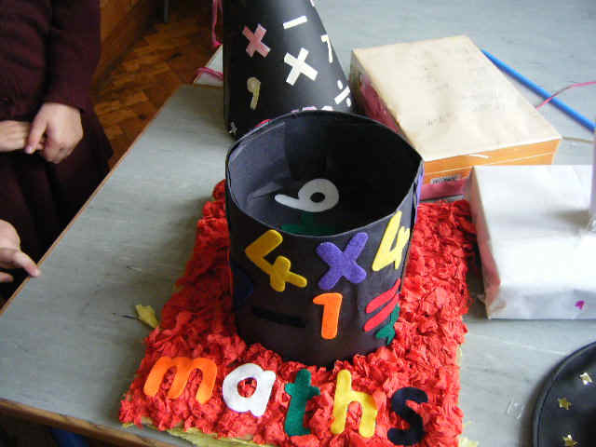

SCOIL MHUIRE MOUNT SACKVILLE N.S. WILL CELEBRATE MATHS WEEK 2020 FROM OCTOBER 12TH-16TH WITH LOTS OF EXCITING ACTIVITIES.

- Maths Problems: Unfortunately this year we are unable to hold our school maths problem solving fair in the hall which was hugely popular last year. Instead each class from Junior Infants-6th will be given maths problems to work on in their classrooms and the children will display the problem using a model or on a chart and present their solutions to their fellow class mates.
- Online maths shows: This year unfortunately schools can not attend the live maths shows like the one Scoil Mhuire attended in the Helix last year. However, there are lots of online maths shows and a daily maths TV programme taking place which are available to view on the maths week website www.mathsweek.ie
- Target-Boards: Target-boards, games and puzzles can be accessed on the maths week website www.mathsweek.ie. Just register with your name, class and email.
- Home/School Links: Tips for parents on how to use maths at home are attached to this email as a separate document.
- Mangahigh Online Maths Activities: These activities are free for children to use during maths week and class teachers will be distributing codes to children for access to this website which is free to use for the month of October. Children really enjoyed this last year and the school even had 2 gold medal winners.
- Useful maths websites for your children to use: Mathplayground, BBC Skillswise, Sum Sense, Nzmaths and Nrich are some of the very useful maths websites to encourage your child to engage in maths activities.
- “Mathseyes” This year a competition will take place where every child tries to take a photo/draw a picture of maths in the environment using their maths eyes. Children should be encouraged to do this at home with their parents. There will be one prize per class. All photos will be returned so make sure children have their names and class on them. They may also wish to upload them onto www.mathseyes.com website where Tallaght IT are running a competition for the best maths photo also. There are some lovely maths eyes activities on the maths week website also.
- There will be a Maths Factor quiz on the school intercom each day for all classes. The winners will receive a golden ticket which entitles them to a night off homework.
- Classes will participate in Maths Trails around the school answering maths questions.
- Children will also be encouraged to participate in some Maths Yard Games during maths week e.g. hopscotch, snakes and ladders, number snail
- We look forward to creating a positive attitude towards maths amongst the pupils in Scoil Mhuire during Maths Week 2020 as they discover elements of maths in their every-day lives. We hope you and your children enjoy having fun with maths in your home.
- We would love you to share any details or photos of maths activities you get up to on our school Twitter account @scoilmhuiremou1

