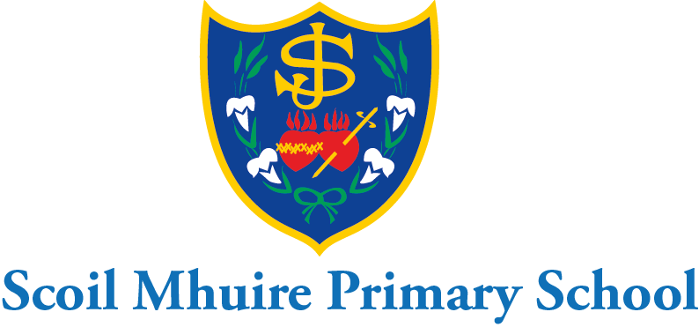

Scoil Mhuire Mount Sackville March Newsletter 2021

Dear Parents/Guardians,
I hope you and your family continue to keep safe and well at this time. Thank you for your continued co-operation and support ensuring the health and safety of all in Scoil Mhuire since our return on March 1st.The school will continue to uphold all health and safety protocols and ask for your continued support with this.
130 years of Scoil Mhuire!:
A new school sign has been erected at the front of the school to commemorate 130 years of Scoil Mhuire Mount Sackville. Hopefully when restrictions ease we can celebrate this as a school community at another time. Scoil Mhuire Mount Sackville primary school was established in 1890 by the sisters of St. Joseph of Cluny. In Scoil Mhuire we are proud of our school and continue to uphold the history, ethos and tradition of the sisters of Cluny. In the words of Annemarie Javouhey their founder, we encourage our pupils to have the "courage to act and the will to succeed". Our school aims to provide a happy, friendly, caring environment where children feel secure and valued in an atmosphere that promotes learning and excellence, allowing each pupil to reach her potential. We look forward to the next 130 years!
Seachtain na Gaeilge:
Scoil Mhuire Mount Sackville celebrated St. Patrick’s Day and Seachtain na Gaeilge with a wonderful Lá Glas to-day. Everyone dressed up in green and engaged in lots of fun activities including a virtual parade. Classes interacted with other classes through zoom and socially distanced in the school yard. Pupils were busy singing and Irish dancing outdoors to celebrate all things Irish. There was even a hunt for a lucky leprechaun! Well done to all the girls and teachers for making Seachtain na Gaeilge and Lá Glas so enjoyable for all.
World Book Day:
World Book Day was celebrated in Scoil Mhuire on March 4th. Children dressed up as their favourite character from a book and brought their book with them to tell their class all about their character and their book. This was a hugely enjoyable experience for all the children. At Scoil Mhuire we continue to promote a love for reading and books at all ages. We encourage parents to read to their children daily. Local libraries can still be accessed online for e-books.
Active School Flag:
This year Scoil Mhuire has introduced the Active School Walkway as part of its work for the Active School Flag. Ms. Ryan has various signs around the school yard pointing out the stops on the walkway. The teachers and children will use this walkway for trails, language & maths activities, sporting activities and exercise breaks. One of the stops on the walkway brings you to our beautiful outdoor classroom adjacent to the school garden. We hope to use the walkway to encourage the children in Scoil Mhuire to be active. Children engage in class busy breaks, active school homework, the Daily Mile, and lots of other sports activities in the school. Scoil Mhuire hopes to celebrate Active School’s week in the summer term also.
Pre&After School Activities:
The BOM have decided to postpone all pre & after school activities for the summer term also. The board appreciate that this will be a source of disappointment to many of our parents. However, I am sure everyone understands the health and safety obligations that the board hold. The board envisages a full return of all pre and after school classes as well as the pre and after school care service in September.

Covid-19 Response Plan:
Our covid-19 response plan and risk assessment are available for all parents to view in the policies section of the school website. I would like to thank the teachers for their continued hard work ensuring the health and safety of all pupils in their class in these difficult, unprecedented times. I would ask all parents to reinforce the good hand hygiene procedures and cough sneeze etiquette with their children each eve. This reinforces all the good procedures teachers maintain each day with the class. We remind parents that pupils must not attend school if they are ill. Any parents whose daughter presents with Covid-19 symptoms such as cough, sore throat, fever, shortness of breath, loss of sense of taste/smell, should not attend school and consult their GP for advice. Please keep the school updated by email at all times. The Return to School Declaration Form must be filled out before returning to school after Easter holidays. This is available on the home page and policies section of the school website. This form must also be filled out after any absence. Parents just need to click on the link, fill out the form and then click submit. I would like all pupils to take home their books for Easter to wipe down and sanitise. Any family/child who may be returning from foreign travel must quarantine before they return to school. It is best for any families affected by this regulation to let us know immediately. I thank you in advance for support with this.

Easter Holidays:

Scoil Mhuire will close at 12:30p.m. on Friday 26th March. To avoid congestion junior and senior infants will need to be collected at 12:00p.m. on this day.1st&2nd class will be on their lines at 12:20pm. 3rd&4th class will be on their lines at 12:25p.m. and 5th&6th class will be on their lines at 12:30p.m.

I would like to take this opportunity to wish you and your family a very happy Easter.

Is mise le meas,

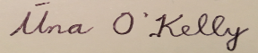
School Principal

