Notification regarding the Board of Management’s review of the Child Safeguarding Statement

To: Monsignor Dan O’ Connor, Archbishop’s house

The Board of Management of Scoil Mhuire Mount Sackville N.S. wishes to inform you that:

• The Board of Management’s annual review of the school’s Child Safeguarding Statement was completed at the Board meeting of 09/09/2021.

• This review was conducted in accordance with the “Checklist for Review of the Child Safeguarding Statement” published on the Department’s ‘website www.education.ie

Signed Date 09/09/21

Chairperson, Board of Management

Signed 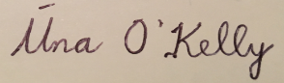 Date 09/09/21

Principal/Secretary to the Board of Management

