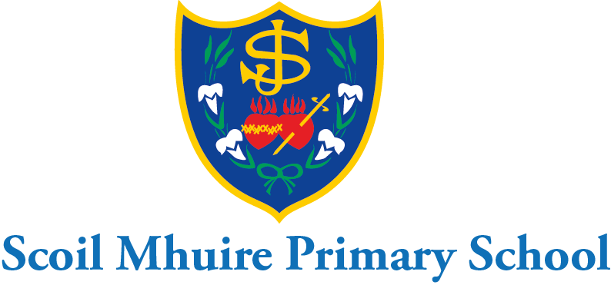

Scoil Mhuire Mount Sackville February Newsletter 2022

Dear Parents/Guardians,
I hope you and your family continue to keep safe and well at this time. Thank you for your continued co-operation and support ensuring the health and safety of all in Scoil Mhuire since our return on January 6th.The school will continue to uphold all health and safety protocols in our covid-19 response plan and ask for your continued support with this.

Punctuality:
We would like to remind parents that if their daughter arrives at school after 9:20a.m. they must be brought to the front school door with their parent/minder. Under no circumstances are pupils to be left in on their own after 9:20a.m. It is important for all pupils to be on time in the morning to avoid disruption to class instruction for all. I would also like to remind parents that we are still operating staggered home times for 1st-6th class until covid restrictions ease. 1st&2nd at 2:50p.m. 3rd&4th at 2:55p.m. and 5th&6th at 3:00p.m. We remind parents that they must collect their daughter punctually at these home times. Please inform the school in advance if there is any change to the collection of your daughter at home time. If a parent is making a collection during the school day the school need to be informed in advance by phone or email. The parent must come to the front buzzer door and the secretary will bring the pupil to the parent then.

Voluntary Contributions
Thank you to those who have already made a voluntary contribution to the school. The BOM really appreciates your generous contributions and they are invaluable in ensuring that the school environment is well maintained, warm, welcoming and conducive to learning.

Safer Internet Day: Safer internet day will take place in Scoil Mhuire on Tuesday,February 8th. Pupils will be engaging in lessons on internet safety from webwise.ie. We remind parents to be vigilant at all times and ensure that their children are not on any social media groups. We advise you to check out the parent’s section of the webwise website which has wonderful advice and support for parents.

Digital Learning:
We are delighted to inform parents that we have recently purchased a set of 16 iPads, cases and charging trolley which cost €7,759. €4,600 of this was raised by the PA through fundraising on the Christmas fun day and fundraising from last year. The remaining €3159 was funded from last year’s voluntary contributions. I would like to thank all the parents for their huge generosity and support with this purchase. We will continue to raise funds to add to this iPad collection. Our mini laptops will continue to be used in the school as well as the iPads.

Hour of Code:
4th and 5th will be participating in an hour of code session with Microsoft. Pupils have found this most enjoyable and beneficial in the past. We are continuing to promote coding amongst the pupils of Scoil Mhuire to enhance their problem-solving skills. Beebots, Lego Wedo 2.0 and Scratch are being used in the school at present.

Wear pink/red day-Amber Flag and St. Valentine’s Day:
Scoil Mhuire will be having a wear pink/red day to celebrate our Amber Flag value of love/value yourself on Feb. 14th. We continue as a school to work at promoting positive mental health and wellbeing. We will be collecting a €2 donation on this day which will go to the Irish Heart Foundation and Pieta House. The PA are also hosting a raffle on this day to raise funds in order to add to our iPad collection. Raffle tickets will go on sale for a €1 a strip on Monday next the 7th Feb.

March 18th-school closure;
Scoil Mhuire Mount Sackville will now be closed on March 18th as the government has approved a day off for all schools on this day in the current school year.

World Book Day:
World Book Day will be celebrated in Scoil Mhuire on March 3rd. Children will be allowed to dress up as their favourite character from a book and bring their book with them to tell their class all about their character and their book. This is always a hugely enjoyable experience for all the children. At Scoil Mhuire we continue to promote a love of reading and books at all ages. We encourage parents to read to their children daily and question them on what they have read. Local libraries can still be accessed online for e-books as well as onsite visits.

School Self Evaluation:
Thank you to all the parents who filled out the reading questionnaire as part of our school self-evaluation on literacy. The findings are now being analysed and a school improvement plan will be drawn up in the coming weeks which will then be shared with parents also.

Seachtain na Gaeilge:
Scoil Mhuire Mount Sackville will celebrate St. Patrick’s Day and Seachtain na Gaeilge with a wonderful Lá Glas on March 16th. Everyone will be allowed to wear something green and will enjoy a céilí in the hall with their class and the Irish dancing teacher. We will be encouraging pupils to make an extra effort to use the cúpla focal at school and at home with their parents during seachtain na Geailge from 1st-17th March. Further information about seachtain na Gaeilge is available on www.snag.ie

Covid-19 Response Plan:
Our covid-19 response plan and risk assessment are available for all parents to view in the policies section of the school website. I would like to thank the teachers for their continued hard work ensuring the health and safety of all pupils in their class in these difficult times. I would ask all parents to reinforce the good hand hygiene procedures and cough sneeze etiquette with their children each eve. This reinforces all the good procedures teachers maintain each day with the class. Pupils in 3rd-6th class must continue to wear masks at school. We ask parents to ensure these pupils bring their mask to school with them every day.We remind parents that pupils must not attend school if they are ill. Any parents whose daughter presents with Covid-19 symptoms such as cough, sore throat, fever, shortness of breath, loss of sense of taste/smell, nausea, fatigue, diarrohea or tummy ache should not attend school and consult their GP for advice. All parents have received the HSE guide for covid isolation by email and should refer to this if in any doubt. Please keep the school updated by email at all times. I thank you in advance for your continued support with this. We will continue to inform the POD and class where there is a positive covid case.

½ day school closure-April 1st:
Scoil Mhuire will close at 12:30p.m. on Friday April 1st as teachers will be engaging with a webinar on the Primary Language Curriculum on this day. To avoid congestion junior and senior infants will need to be collected at 12:00p.m. on this day.1st&2nd class will be on their lines at 12:20pm. 3rd&4th class will be on their lines at 12:25p.m. and 5th&6th class will be on their lines at 12:30p.m.

I hope you and all your family continue to stay safe and well at this time.

Is mise le meas,

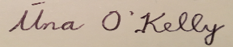
School Principal

