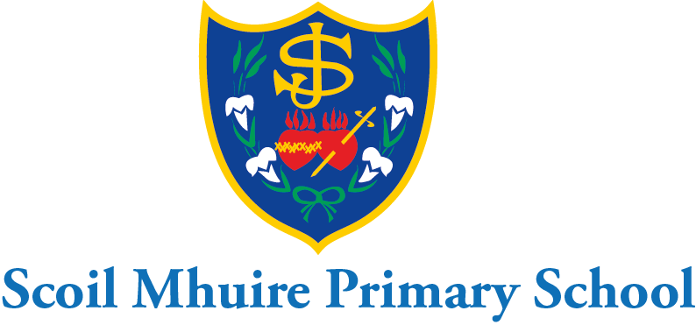

Scoil Mhuire Mount Sackville March Newsletter 2023

Dia dhaoibh a thuismitheoirí!

We were delighted to receive delivery of four beautiful new buddy benches for our yard yesterday. Thank you to the P.A. and all the parents for fundraising these from our Christmas fair. The pupils are delighted with them and the green school committee are very happy that they are made from 100% recycled materials! We hope the pupils enjoy many years on these benches with their friends.

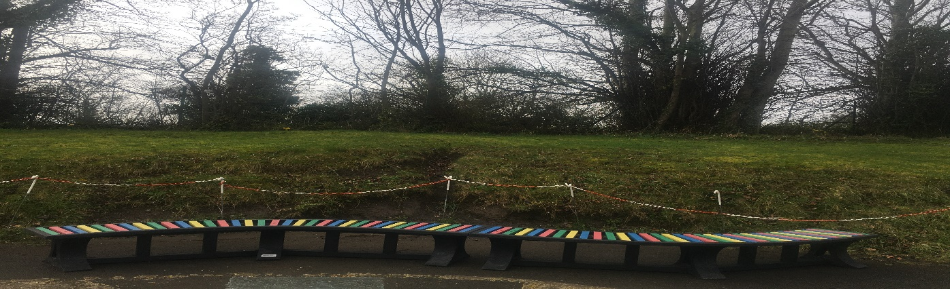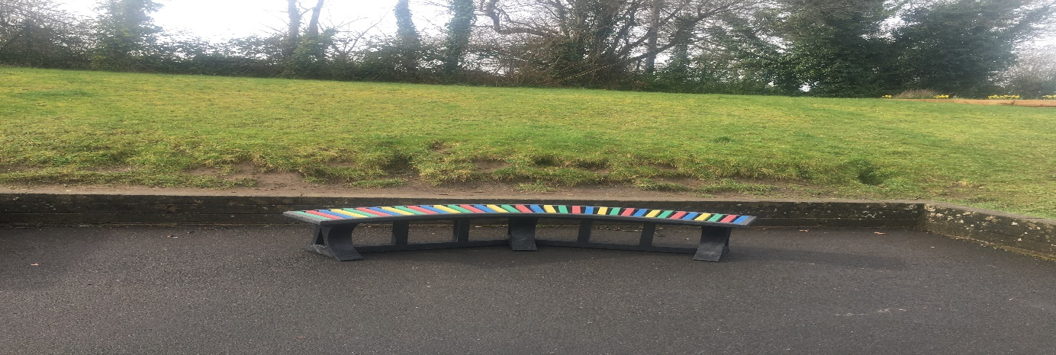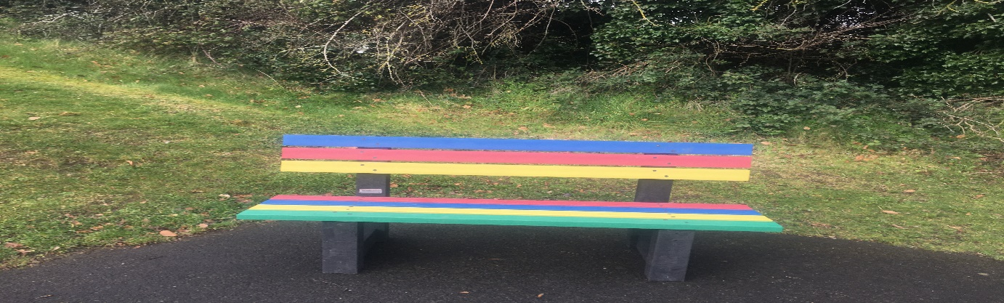

Safer Internet Day: Safer internet day took place in Scoil Mhuire on Tuesday, February 7th. Pupils engaged in lessons on internet safety from webwise.ie. The student council assembled our safer internet code for all pupils to view in the school hall. We remind parents to be vigilant at all times and ensure that their children are not on any social media groups. We advise you to continue to check out the parent’s section of the webwise website which has wonderful advice and support for parents.

Wear pink/red day-Amber Flag and St. Valentine’s Day Raffle:
The P.A. Valentine's charity raffle was held on wear pink/red day in February. Pupils wore something pink/red to celebrate our Amber Flag value love/value/be kind to yourself. In Scoil Mhuire Mount Sackville primary school we continue to promote positive mental health and wellbeing through our Amber flag values. There were lots of great teddy and voucher prizes for each class and a huge teddy also for the whole school. Over €1300 was raised from the raffle which went to UNICEF to help relief work for the Earthquake disaster in Turkey and Syria. Our prayers and thoughts are always with the people in these two countries which have been affected by the earthquake.

World Book Day:
World Book Day was celebrated in Scoil Mhuire on March 2nd. Children were allowed to dress up as their favourite character from a book and bring their book with them to tell their class all about their character and their book. This was a hugely enjoyable experience for all the children. At Scoil Mhuire we continue to promote a love of reading and books at all ages. Buddy reading and book club are proving hugely popular at present. We encourage parents to read to their children daily and question them on what they have read. Local libraries can still be accessed online for e-books as well as onsite visits. The link to the google form for our literacy school self-evaluation has been sent again to-day to parents for anyone who didn’t get a chance to fill it out the first time. When all the forms are submitted the results will be analysed, compared to last years and shared with parents to provide information on reading and comprehension habits amongst our school community.

Active School Flag:
The active school committee and Ms. Donohoe have been very busy with their Feel-Good Friday challenges of “climb the heights” skipping and “pump up the volume” dance challenge. The active school flag organisation thought they were so good that they sent the school 5 lovely table tennis sets as a reward. Lovely to see pupils active and enjoying themselves.

Fingal Athletics League:
The pupils from 3rd-6th class had a wonderful morning at the Fingal Athletics League in sunny Porterstown last Tuesday. They all put in an incredible performance in their races. It was lovely to see the senior girls cheering on the junior girls as they competed. Great day out had by all. We look forward to the next round next Tuesday and the final at the end of April. Morning running club is still open to all pupils from 3rd-6th with Ms. Donohoe.

Leinster hockey league:
Congratulations to Ms. Carroll and the 6th class hockey team who will be competing in the semi-final of the Leinster hockey league tomorrow in Rathfarnham. They have shown great sportsmanship and teamwork throughout the competition. We wish them the very best of luck!

School Quiz team:
Well done to Ms. Clifford and the 6th class school quiz team who reached the regional finals of the school’s credit union quiz and achieved third place in the Phoenix 92.5 FM school’s radio quiz. Wonderful teamwork displayed throughout the competitions.

National Children’s Choir:
5th class are very excited as their concert in the National Basketball Arena draws near on Friday, April 21st. They have been practising very hard with Ms. O’ Malley over the last few months and now have only two rehearsals to go until the big night. They will perform some of their repertoire for the nuns in the convent to-day as part of the St. Patrick’s day festivities.

Creative Schools:
After the successful bake-off event at Christmas our creative school plan is ready to embark on some more creative initiatives. We hope to have a Junk Couture design event the week before Easter where pupils will get input on how to design their own “junk couture” in class. In the last term we hope to finish our creative school’s initiatives for this year with some expert input on podcasting. We would hope that the pupils would then be able to make their own school podcasts. This could be integrated with our digital learning plan also. Thank you to Ms. Kelly for organising this with the creative associate.

Building updates:
All the lines and games in our school yard in the junior infant section will be painted during Easter holidays with a few more yard games added in also. After our very successful job on installing a new P.E. hall floor we are now seeking an emergency works grant again-this time to replace all the cast iron gutters and fascia boards at the back of the school. If successful we hope to complete this work during the summer holidays.

Voluntary Contributions
Thank you to those who have already made a voluntary contribution to the school. The BOM really appreciates your generous contributions and they are invaluable in ensuring that the school environment is well maintained, warm, welcoming and conducive to learning.

Seachtain na Gaeilge:
Scoil Mhuire Mount Sackville will celebrate St. Patrick’s Day and Seachtain na Gaeilge with a wonderful Lá Glas tomorrow March 15th. Everyone will be allowed to wear something green and will enjoy a céilí in the hall with their class and the Irish dancing teacher. We will be encouraging pupils to make an extra effort to use the cúpla focal at school and at home with their parents during Seachtain na Gaeilge this week. Further information about seachtain na Gaeilge is available on www.snag.ie Junior infants, senior infants and 5th class are visiting the nuns in the convent to-day to perform some songs for them. It has been 4 years since we have been able to do this due to covid restrictions. On Thursday we look forward to having a ceolchoirm beag in the school hall where each class will perform a song/poem/dance for all the classes in the school. Thank you to Ms. Finneran for organising this. It is wonderful to be able to celebrate events together again.

March 20th-school closure;
I would like to remind you that Scoil Mhuire Mount Sackville will be closed on Monday March 20th as well as St Patrick’s day March 17th.

Don’t forget you can keep up to date with all our news on the school website www.scoilmhuiremountsackville.ie or by following us on twitter @scoilmhuiremou1

Wishing you all a wonderful St. Patrick’s weekend.

Beannachtaí na Féile Padraig oraibh go léir!

Is mise le meas,

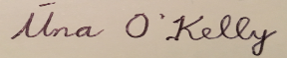
School Principal
Scoil Mhuire Mount Sackville

