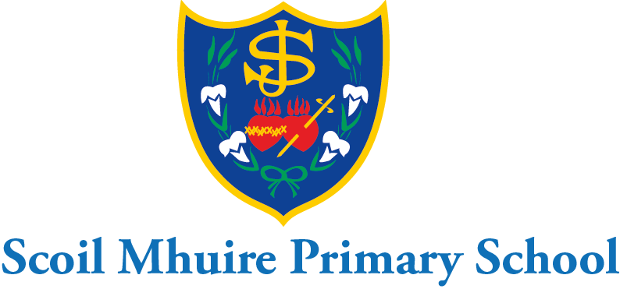

Scoil Mhuire Mount Sackville April Newsletter 2022

Dear Parents/Guardians,
I hope you and your family continue to keep safe and well at this time. Thank you for your continued co-operation and support ensuring the health and safety of all in Scoil Mhuire Mount Sackville over the past term.

Covid-19:
I would like to thank the teachers for their continued hard work ensuring the health and safety of all pupils in their class at this time. I would ask all parents to reinforce the good hand hygiene procedures and cough sneeze etiquette with their children each eve. This reinforces all the good procedures teachers maintain each day. We remind parents that pupils must not attend school if they are ill. Any parents whose daughter presents with Covid-19 symptoms such as cough, sore throat, fever, shortness of breath, loss of sense of taste/smell, nausea, fatigue, diarrohea or tummy ache should not attend school and consult their GP for advice. Any pupil who has symptoms must be 2 days free of symptoms before returning to school. Please keep the school updated by email at all times. If your daughter is a close household contact we would ask you to ensure she wears a mask at school to protect the teacher and other pupils in the class. I thank you in advance for your continued support with this. We will continue to inform the class where there is a positive covid case.
Punctuality:
We would like to remind parents that if their daughter arrives at school after 9:20a.m. they must be brought to the front school door with their parent/minder. Under no circumstances are pupils to be left in on their own after 9:20a.m. It is important for all pupils to be on time in the morning to avoid disruption to class instruction for all. We remind parents that they must collect their daughter punctually also at home time. Please inform the school in advance if there is any change to the collection of your daughter at home time. If a parent is making a collection during the school day the school need to be informed in advance by phone or email. The parent must come to the front buzzer door and the secretary will bring the pupil to the parent then.

Voluntary Contributions
Thank you to those who have already made a voluntary contribution to the school. The BOM really appreciates your generous contributions and they are invaluable in ensuring that the school environment is well maintained, warm, welcoming and conducive to learning.

Zeeko Cyberbullying workshops:
Zeeko will be delivering cyberbullying and internet safety workshops to all pupils in 3rd-6th class on the 5th May during the school day. They will deliver a special parent workshop online for parents of pupils in 3rd-6th on May 5th from 7-8p.m. An online invitation will be emailed to parents before this date. Teachers will be availing of a cyberbullying and internet safety workshop after school on Wednesday the 4th May. We continue to remind parents to be vigilant at all times and to ensure their daughter is not on any social networking sites or groups.

School Self-Evaluation in Literacy:
All parents recently received a copy of the school improvement plan for literacy which was devised based on the analysis of findings from parent questionnaires, pupil questionnaires and standardised test results. As the plan outlined we are focusing as a school on the area of comprehension in reading. We ask you to support the plan by encouraging your child to read and discuss with them about what they have read. We also encourage parents to allow their child to be a member of their local library to aid their independent reading. As a school we will continue to implement this plan in the next academic year also.

Digital Learning:
We are delighted to inform parents that we have recently purchased another 2 iPads to add to our collection with the raffle money from St. Valentine’s day. We now have 18 iPads in total. I would like to thank all the parents for their huge generosity and support with this purchase. We will continue to raise funds to add to this iPad collection. Our mini laptops, Beebots and Legowedo 2.0 will continue to be used in the school as well as the iPads.

Creative Schools:
Scoil Mhuire is delighted to have been accepted to take part in the creative school’s project. At present a creative associate is working with the school to gather findings on creative experiences of the pupils so far and ideas on future creative experiences. She is also meeting with the staff this week to discuss the creative schools project and the creative possibilities for the pupils in the year ahead. The school will be in touch with parents about this in due course to gather more information and ideas. The project hopes to stimulate and harness the creativity that is present in all pupils. Funding has been granted to the school to support initiatives carried out as part of the creative school’s project

Acitve School’s week:
Active school’s week will take place from May 2nd-6th all over Ireland this year. Scoil Mhuire Mount Sackville will celebrate active school’s week with daily active breaks, active homework and use of the active school walkway activities. We continue to work as a school towards our active school flag.

GAA Coaching:
David Moran the GPO form St Brigid’s GAA has been working with Junior infants-2nd since January on their GAA skills. It was wonderful to see all the girls so active every Friday and enjoying themselves as they learned new skills. 3rd- 6th class will be commencing their GAA coaching on Friday, 29th April after Easter.

First Communion and Confirmation:
First communion will take place @12p.m. on Saturday, 7th May in Our Lady mother of the Church, Castleknock. Confirmation will take place @12p.m. on Friday, 20th May in Our Lady Mother of the Church, Castleknock. It is a long tradition in Scoil Mhuire Mount Sackville that 5th class sing as a choir for the communion and confirmation ceremonies. On the confirmation day the school will be bringing the 5th class pupils on the bus to the church and bringing them back to school after the ceremony again. We ask the support of the 5th class parents to drop their daughter to the church on the 7th May to be seated in the balcony for 11:45p.m. and to be collected after at 1pm. The ceremony is always enriched by the wonderful singing of the choir and we appreciate your support with this.

½ day School Closure:
Scoil Mhuire will close at 12:30p.m. on Friday, May 27th as teachers will be engaging with the 5th webinar on the Primary Language Curriculum on this day. To avoid congestion junior and senior infants will need to be collected at 12:00p.m. on this day.1^{st-6th} classes will be collected at 12:30p.m.

Easter Holidays:
Scoil Mhuire will close at 12:30p.m. on Friday 8th April. To avoid congestion junior and senior infants will be on their line for collection at 12:00p.m. 1st-6th class will be on their lines for collection at 12:30p.m.

I would like to take this opportunity to wish you and your family a very happy Easter.

Is mise le meas,

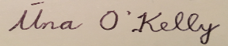
School Principal

